RESUME
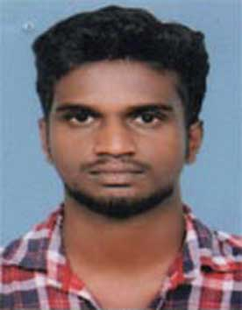
HARIKRISHNAN S
Sreekandeswarath Myalil House
Manjoor P.O
Kottayam Dist.
Kerala - 686603
Ph: 8086798752
Email: hariharikrishnan343@gmail.com

Objective

Seeking a position to utilize my skills and abilities that offers professional growth while being resourceful, innovative and flexible.

Professional Experience

Working as Machine Operator in Amphenol FCI, Mulamthuruthy, Kerala for the last 4 years.

Academic Profile

Qualification | University/ Board | Institution | Year of Completion | % of marks
ITI (Machinist) | NCVT | Govt. ITI, Ettumanoor | 2013-15 | 68.48
Plus Two | Board of Higher Secondary Examination, Kerala | Govt. HSS, Vayala | 2014 | 62.58
SSLC | Board of Public Examinations, Kerala | VKVM NSS HS, Manjoor | 2011 | 72

Computer Knowledge

- Windows and MS Office

Personal Attributes

- Hardworking and dedicated
- Adaptability
- Flexibility
- Can take leadership
- Active, helpful and contributing team member
- Reliable and punctual
- Willing and able to travel and relocate

Personal Information

Age & Date of Birth : 24, 23.05.1996
Gender : Male
Permanent & Present Address : Sreekandeswarath Myalil House
Manjoor P O
Kottayam Dist.
Kerala - 686603
Phone : 8086798752
Email : hariharikrishnan343@gmail.com
Marital Status : Single
Father’s Name : Sadanandan A K
Languages known : English, Hindi and Malayalam
Religion with Caste : Hindu, Viswakarma
Nationality : Indian

Declaration

I hereby declare that the above mentioned details are true and correct to the best of my knowledge and belief.

Place: Manjoor
Date: HARIKRISHNAN S

